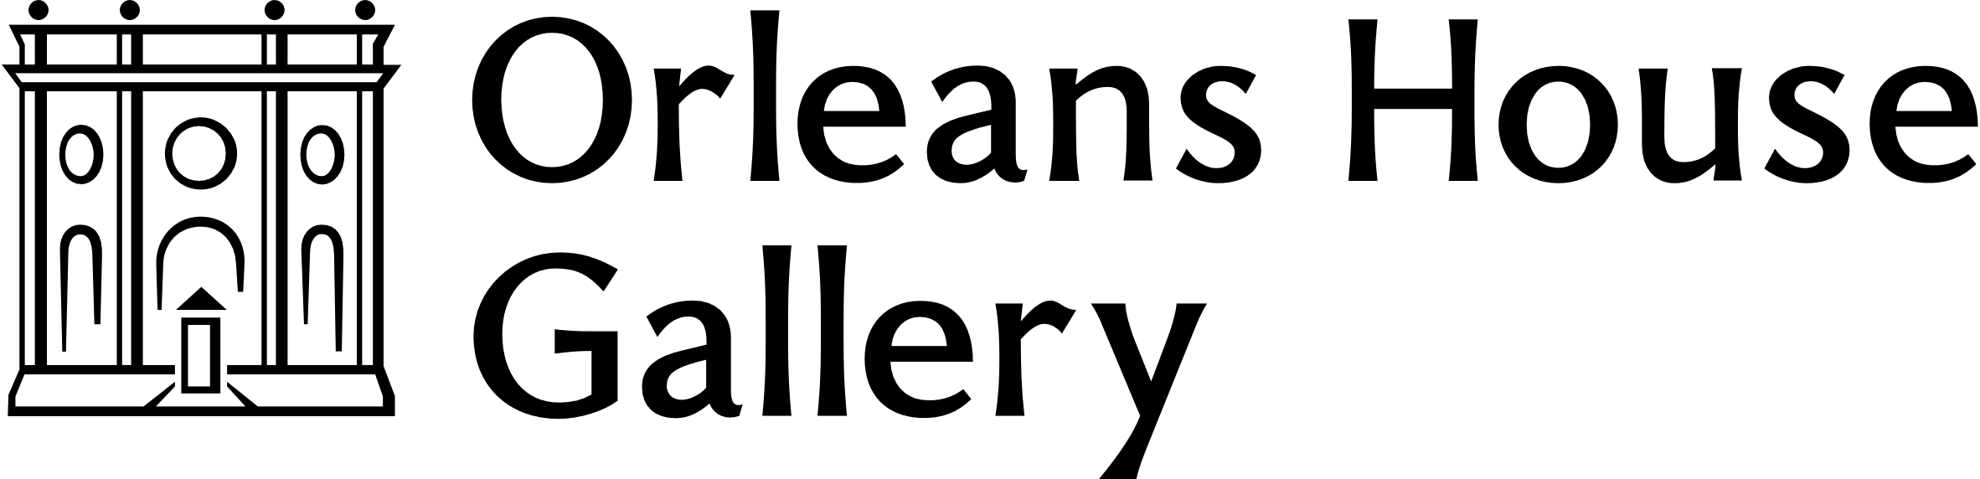
Curious Tots (Spring/Summer 2022) Lead Artist Facilitator
Richmond Arts Service and Orleans House Gallery is seeking a freelance artist with experience and/or an interest in working with early years and their parents and carers for our ongoing workshop series Curious Tots.
Deadline for applications: Midnight, Sunday 28 November

About Us
Orleans House Gallery is a contemporary art gallery set in grounds overlooking the River Thames in Twickenham. It is managed by Richmond Arts Service which is part of the London Borough of Richmond upon Thames.
Our mission is to build community through creativity. We foster creativity and enjoyment of the arts, enable people to reflect on their lives and develop new ways of seeing the world.
We have recently launched our new programme of activities for early years and children at Orleans House Gallery, enabling families to take part in a variety of inspiring workshops led by professional artists.

Artist Brief
Launched in June 2021, Curious Tots is our ongoing artist-led workshop series for toddling and pre-walking children and their parents/guardians that combines music, storytelling, sensory play and gentle interaction. Each term of workshops is delivered by a different artist, enabling audiences to engage with a range of artistic practices.
We are looking for an artist to be the lead facilitator of our next term of workshops and to develop and deliver sessions that meet the below aims:
- Nurture curiosity and creativity and encourage interaction and play between toddling and pre-walking children and their parents/guardians.
- Are relaxed and informal and welcoming to new parents.
- Invite audiences to engage with the lead facilitators own artistic practice.
- Support the Early Years Foundation Stage (EYFS) framework.
- Support early years skills development in social interaction and communication.
- Where appropriate or relevant take thematic inspiration from Orleans House Gallery and grounds, current exhibitions and the Richmond Borough Art Collection
Each workshop date should feature different elements to the workshop in case there are returning audiences but there might be some repeated features (i.e. a welcome and goodbye song for example).
Sessions will be ticketed with a maximum capacity of up to 12 family units (most likely 1 adult, 1 child) in each workshop.
The workshop should be planned to last between 40-45 minutes.
All sessions will be held onsite at Orleans House Gallery.
Responsibility for the artist include:
- Plan and deliver all Curious Tots sessions responding to feedback and input from staff.
- Adhere to all Richmond Arts Service Safeguarding and Health and Safety procedures.
- Set-up and pack down the workshop space.
- Supply and manage necessary materials for the sessions.
- Support the effective evaluation of the programme.
- On occasion, be the only member of staff in the session.

Key Dates
- Deadline for Applications: Midnight, Sunday 28 November.
- Informal Interviews (virtual): w/c 6 December
- Notification of Outcome: Friday 10 December
- Artist to develop session plan (including one check in with Arts Officer): January 2021
- Delivery Dates (you must be available for all these dates and will be needed from approx. 9.30am-1pm)
  - Tuesdays: 1/15 February // 1/15/29 March // 12/26 April // 10/24 May // 7/21 June // 5 July
  - Sessions will take place at 10.30am and 11.45am on each day.
- An evaluation meeting will be scheduled following the final session.

About You
This opportunity would suit an artist with experience in facilitating sessions for early years.
You will:
- Have experience of, and be confident with, applying your artistic practice to an existing workshop model. developing workshops that share your own artistic practice with audiences
- Have demonstrable facilitation skills including being able to plan sessions and adapt to changing circumstances.
- Be confident in combining a mixture of music, song, storytelling, movement, and sensory play suitable for early years.
- Have demonstrable skill and expertise in one or more of the following art forms: music, singing, storytelling or dance.
- Have experience of working creatively and responsively with a diverse range of audiences.
- Have the desire to work with early years and their adults.
- Have the ability to work in a collaborative manner with all members of staff and volunteers at Orleans House Gallery.
The successful applicant will be required to hold or be willing to carry out an Enhanced DBS (Disclosure and Barring Service check) through Richmond Borough Council, as well as adhere to all Safeguarding and Health and Safety policies and procedures.
We are keen to work with artists from a variety of backgrounds with different skills, stories, and experiences. Applications are encouraged regardless of age, caring responsibilities, disability, sex, gender identity, marriage and civil partnership, pregnancy and maternity, race, religion or belief, and sexual orientation.

Fee
There is a freelance fee available of £2100 (£150 per session (x12) plus a £300 planning fee). This is an inclusive fee covering all expenses.
There is a small materials budget available to be managed collaboratively with the Arts Officer (Projects and Commissioning). Requests for additional materials should be made in good time and be essential for workshop delivery.
Artists are responsible for their own tax and National Insurance.

How to Apply
Deadline for applications is midnight on Sunday 28 November 2021.
Applications can be submitted in writing, by voice-recording or video and should include the following:
- Full contact details.
- A link to your website, relevant social media platforms and/or a copy of your CV (max 2 pages) which demonstrates previous examples of relevant experiences.
- A short statement (no longer than 500 words or 3 minutes) outlining your interest in the project and how you would approach the brief.
- The names and contact details of two referees. They will not be contacted before asking your permission.
Please send applications to alex.williams@richmondandwandsworth.gov.uk with the subject line OHG_Curious Tots_Spring-Summer 2022_Your Name.
Please do not send Drobox, Google Folders, or WeTransfer links. If you need to transfer any larger files (such as a video file) please get in touch first.
We are committed to making application processes as accessible as possible. If we can provide you information in a different format or you have any questions regarding this opportunity, please contact alex.williams@richmondandwandsworth.gov.uk.

Equal Opportunities
Richmond Arts Service collects equality and diversity information from all artists applying to work with the service. Collecting responses to the questions allows us to gather information (or data) that helps us to ensure we are working with a diverse range of artists.
Whilst submitting your application please also complete our Equal Opportunities Monitoring Form to help us with this.
All information entered into this form is gathered anonymously and will be stored separately from any identifying information or your application. It will not impact on the outcome of your application in any way.

Selection Process
We will be shortlisting artists on the following criteria:
- How you meet the criteria for the role using the information provided in the “About You” section.
- How closely your approach meets the requirements of the brief.
- Alignment with our vision and values.
We will respond to all applications no later than Friday 3 December.
We will invite a selection of applicants to have an informal interview via Zoom with the Orleans House Gallery Team prior to making a decision. These conversations will be scheduled for w/c Monday 6 December. They are intended as a way for both parties to meet one another and ask questions. You will not be required to prepare anything in advance.

