

POPE’S GROTTO
Who was Alexander Pope?

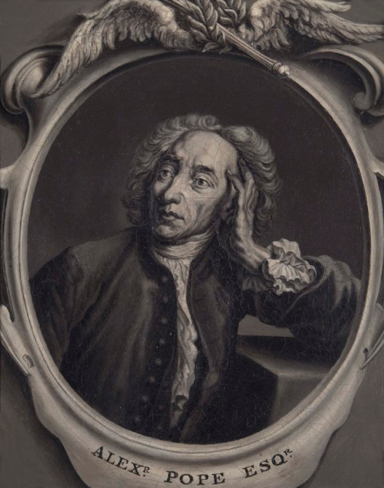
I was a famous poet and satirist (a writer who criticises humorously) who lived from 21 May 1688 – 30 May 1744. Lots of quotes from my work are still used today.

An example of a Pope Quote:
Fools rush in where angels fear to tread.
This means people with bad judgement rush into situations which more cautious people might avoid. This is from a 1711 poem called An Essay on Criticism.

- In 1719, Pope moved from Chiswick to Twickenham, where he leased land and had his own home built. He didn’t own the land.
- The house was designed by James Gibbs (who also designed the Octagon Room at Orleans House Gallery).
- The design was Palladian.
- The villa itself was demolished in 1808.
Where did Pope live?

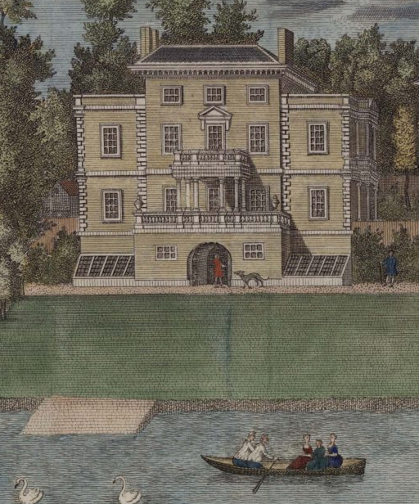

What does Palladian mean?

It is a style of architecture which is symmetrical (imagine a line down the middle of the house – the two halves will be a mirror image of each other) and it uses shapes inspired by Roman and Ancient Greek design. What shapes can you see in the picture of his villa?

Images produced by permission of the London Borough of Richmond upon Thames Borough Art Collection, Orleans House Gallery unless otherwise stated.

Where was Pope’s Grotto?
The house sat along the river Thames and so Pope leased land on the other side of the road Cross Deep for his gardens. He had a tunnel built under the road to connect the two together. The grotto was in the basement of the house and eventually extended along the tunnel. The basement is in the semi-circle at the bottom of the picture on the previous page.

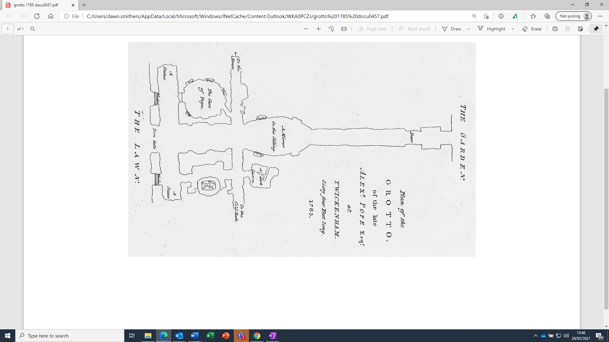

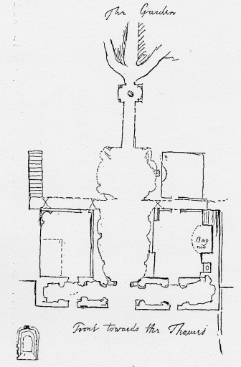
Can you see the changes in how the grotto grew from these two images?

It started in the middle chamber and grew into the side rooms of the basement and along the tunnel.

© Pope’s Grotto Preservation Trust

© Pope’s Grotto Preservation Trust
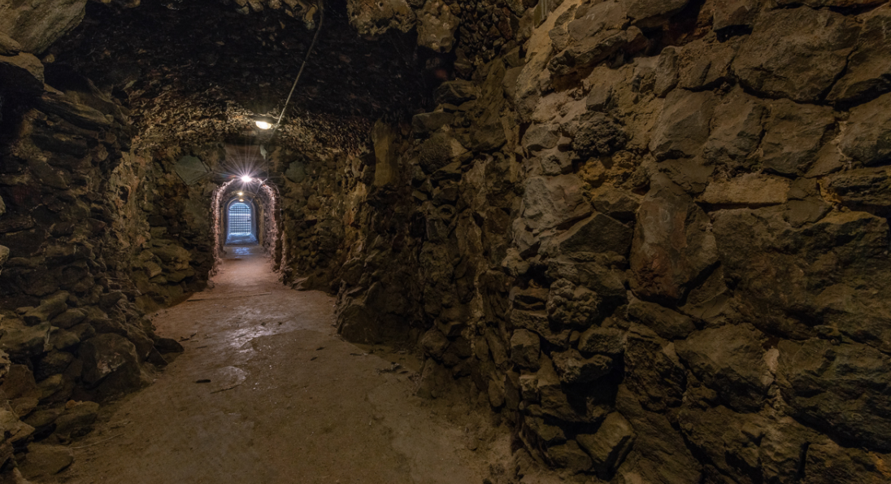
© Damian Griffiths
What is a grotto?
Pope’s Grotto was a manmade cave in the basement of his house. It grew to run through the tunnel and the entire basement.
- The grotto was decorated with materials that his friends would send from their journeys, but later he became interested in geology and minerals and his friends would send him deliveries of materials from Cornish tin mines and stone from Bath.
- The grotto was made up of rock, stone, petrified wood, fossils, glass, coral, shells and even humming-bird nests made up part of the collection.
- Materials came from the UK, but also Norway, Germany, Peru, the West Indies, Italy, Egypt, Spain and Brazil.

It was 'full of light and open' with smooth stones and the other as 'rough with shells, flints and iron ore, pav'd with simple pebble.'

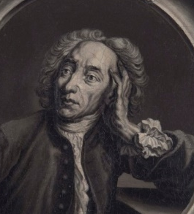
Why do you think Pope wanted to make the grotto?

The grotto has survived, but it needs looking after. A lot of the wonderful objects that adorned the walls are now gone and the gardens which they led into are also no longer there.
Orleans House Gallery is working with the Pope’s Grotto Preservation Trust to help tell the story of Pope and his Grotto through family workshops. The Pope’s Grotto Preservation Trust are working in partnership with Radnor House School (who own the site of the Grotto) are now starting a Lottery-funded project to conserve the grotto and run a programme of activities about Alexander Pope. Find out more here: https://popesgrotto.org.uk/ including information on visiting the grotto which is open to the public from time to time.
Visit https://www.orleanshousegallery.org/ for more information on Orleans House Gallery.

The Grotto Today
Imagine that you are in the grotto. You are in the basement of the villa and walking towards the gardens. All around you are stones, shells and rocks jutting out from the walls. The space is small, and the air is moist. Light shines off the fragments. How would it make you feel?

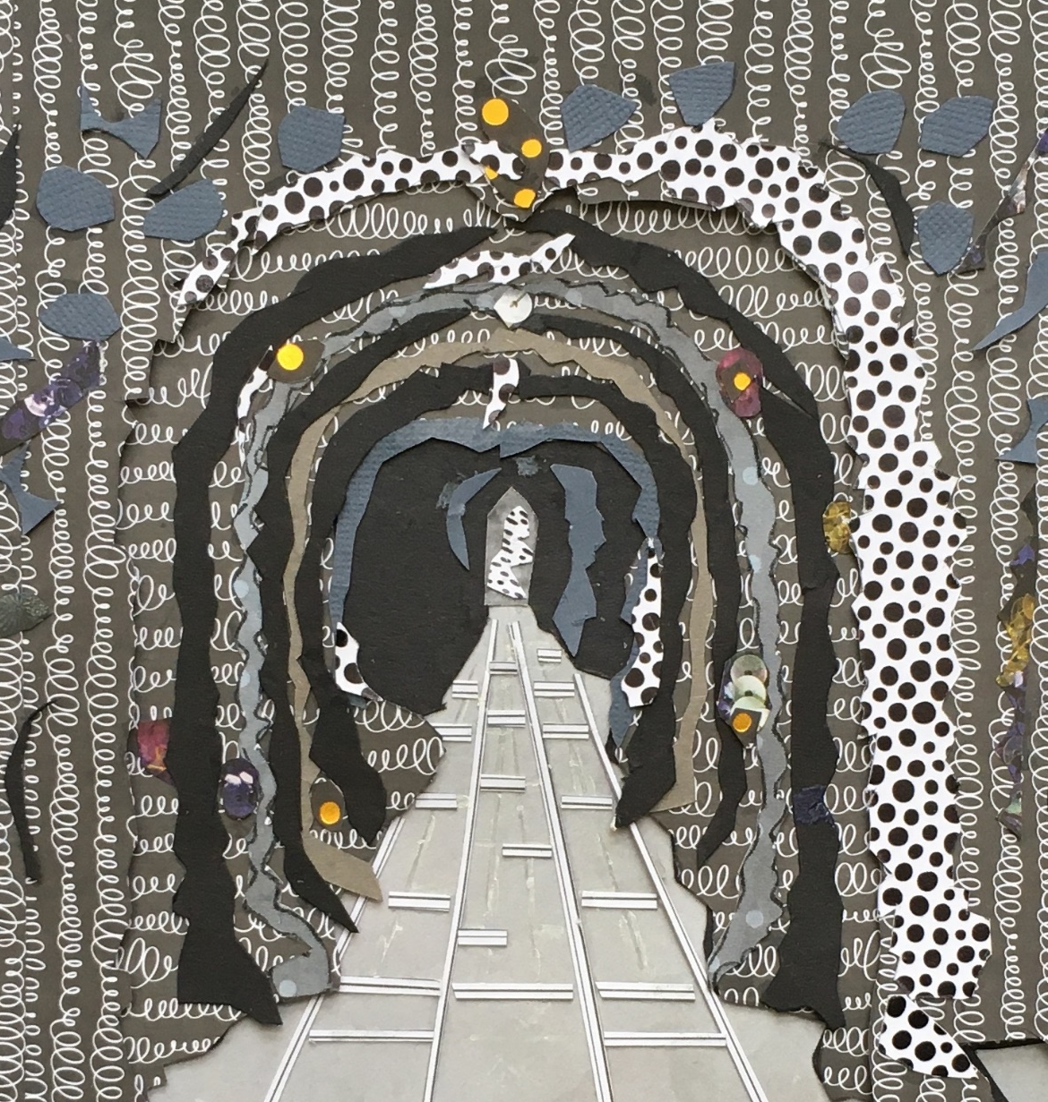

Why do you think it is important to preserve the grotto?

© Sasa Marinkov

