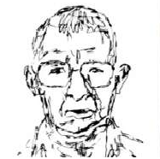
Self Portrait!
Inspired by artist Martin Davison (who had a 2016 exhibition at the Stables Gallery), create a self portrait.
Imagine what you’ll look like in the future!

FUTURE
NOW

