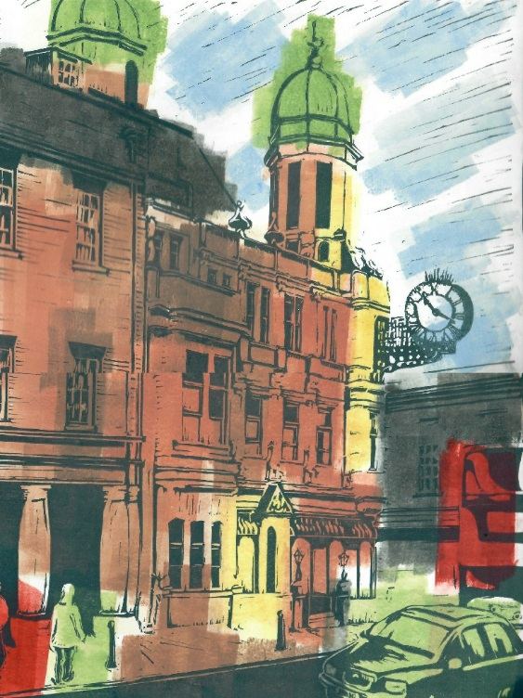
Imprinted Memories

In 2019, the Riverside Gallery housed a group show by Wednesday Printmakers.
In his linocut print, Old Town Hall, David Natas has used blocks of colour and lines to recreate the memory of a place.

In the box below, draw a special memory of your own!

