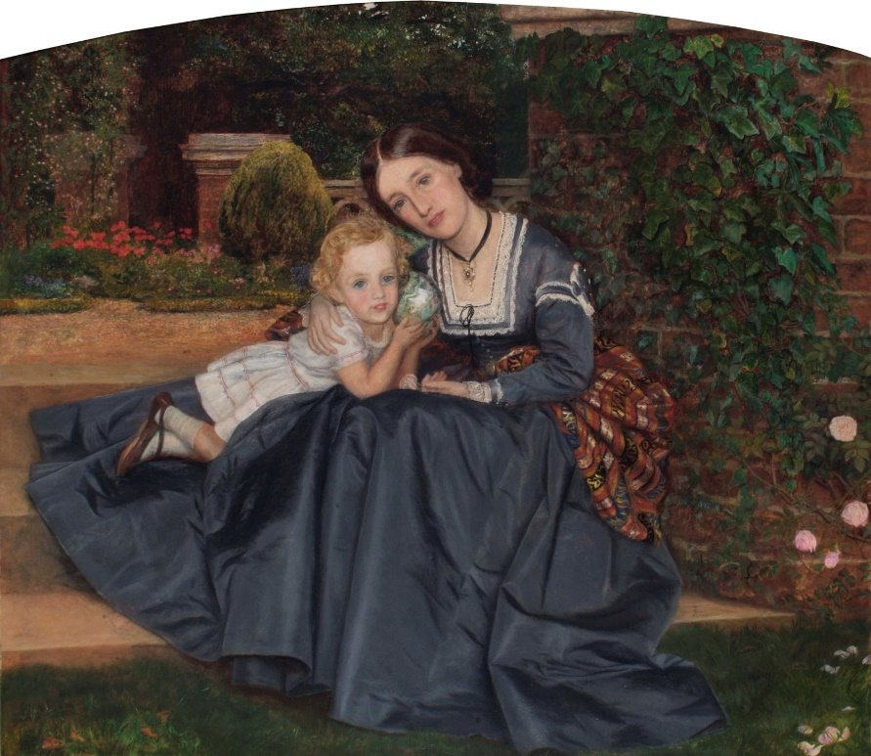
Family Portrait
Look at this painting by Arthur Hughes called Mother and Child seated in Garden from 1865-70 (circa). It is one of the images in the Borough Art Collection.
In the box below, or on another sheet of paper, have a go at drawing your family or other important people from your life. Where will you be? Don’t forget to name your artwork at the end.

