How to make your own flower wheel:
- You will need: the template below, scissors, colouring materials, glue, a split pin or drawing pin (if using a drawing pin, you will need a stopper for the back such as a Styrofoam ball or an earring back), something sharp to make a hole with, a paper straw (or similar). You will also need a ruler and a pencil if you are drawing your own template.
- Cut out the template below. You can easily make your own if you do not have a template. Simply make a 14.5 x 14.5 cm square on some paper or thin card. Draw a faint line from the four corners. Draw a dot at the intersection in the middle. Measure 7cm from the corner towards the middle and draw a thick line. Draw 4 small dots in the corner, missing every other section and you will have the same template as below. Make sure that if you have drawn your own design that you only cut the thick lines from each corner – towards the middle for about 7cms.
- Colour it in! For best results, you should colour in both sides.
- Fold lightly in half and cut out the central circle (you do not need to do this if you are using a drawing pin).
- Snip off the 4 little circles you have drawn (you do not need to do this if you are using a drawing pin).
- Glue the middle of the template around the hole/dot.
- Stick each of the snipped corners down into the middle, making sure the hole is not obscured. If you have not cut them off as you are using a drawing pin, then overlay all the small dots on the bigger central dot.
- Take a paper straw and flatten one half, or a strip of cardboard from a cereal box or a kitchen roll tube and ask an adult to make a hole with something sharp (a pin or a compass).
- Push a split pin through the centre of your design and then through the straw. Push down the strips at the back. Do this loosely as you want the wheel to have some give and to move. If using a drawing pin, push this through as above and make sure you cover the sharp point.
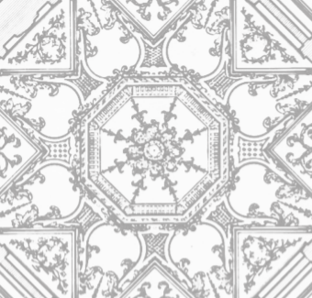
- Voila. Go out in the wind or blow on the wheel.

