Endangered Animals!
In 2017, the Riverside Gallery hosted an exhibition about endangered animals. The exhibition was of work created by artist Susan Gibbons responding to the plight of endangered animals. Endangered animals often use their habitat (where they live) and surroundings to hide from poachers (and other predators) who want to harm them. Some animals use dense forest while others use snow.
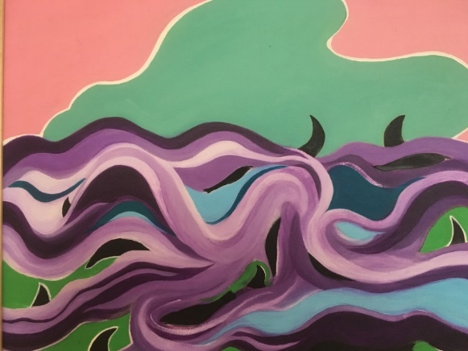
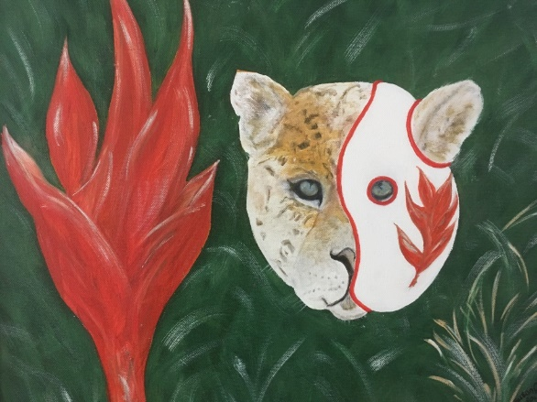
Look at the images below of Susan’s work and then create your own image of an animal hiding in the habitat.
