See Saw @ Home – Create Pattern Heads
Inspired by William Hogarth’s work, Characters and Caricaturas from 1743, let’s make our own picture of lots of heads.
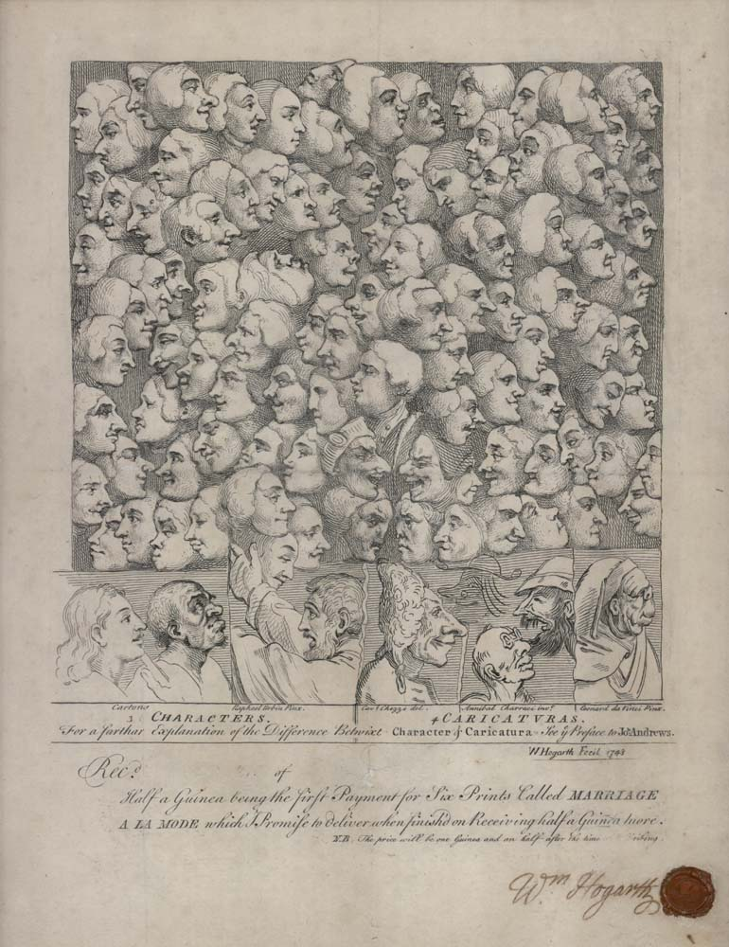
You will need:
- Paint
- Pens
- Paintbrush
- Paper (any colour)

- Paint your fingertips.
- Print rows of spots on the paper. You can print the same colour or different colours, it’s up to you. You can print more than one sheet with fingerprints. Here is an example.
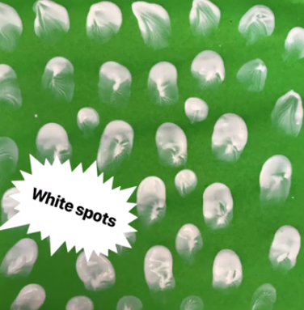
- Wait for the paint to dry.
- Take a pen and turn the spots into heads by adding eyes and other features. What sort of heads are they? Maybe you will add noses and ears too. What about whiskers?

