See Saw @ Home – Create Big and Small Movements
For this activity, you will need some space to stand and move your body around. Follow the instructions on the video or here.
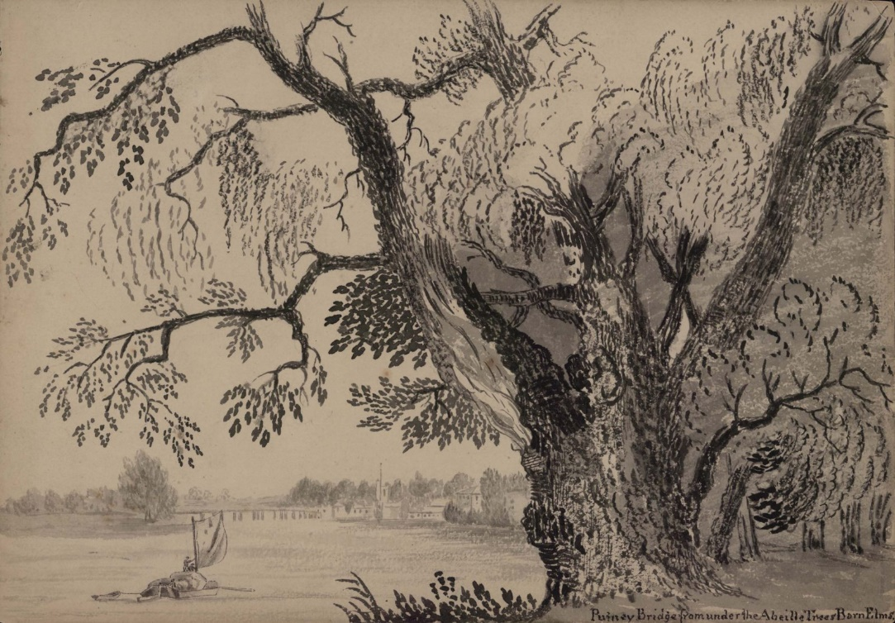
This is a pen and ink drawing by John Claude Nattes. It is called Putney Bridge from under the Abeille Trees, Barn Elms.
We are going to move our bodies in big and small movements inspired by this picture. We can see a big tree and a small boat and trees, houses and a bridge in the distance. Imagine that you are in the picture looking at the tree.
- Take some big steps towards the tree. One. Two. Three. We are now under the tree. Look at the bumpy, lumpy bark.
- The tree used to be a tiny seed. Curl your body up into a tiny ball as if you were a seed. Make your body as small as you can.
- Let’s grow upwards like the tree. Stretch out your arms and slowly stand up. Reach up for the sky. Stretch your arms out as wide and far as they will go.
- The wind starts to blow. Sway your arms from side to side. First make small movements, like you are gently swaying in the breeze. Make bigger movements as the wind gets stronger. Your arms are the branches of the tree.
- Stretch your fingers like they are small finger twigs in the trees. A small bird comes and rests on your twigs. What colour is it? Its wings flap gently in the breeze. Can you feel it?
- The bird knocks a leaf from your finger twigs and the leaf begins to spin and tumble to the ground. Can you spin your body around and float gently to the ground just like the leaf?
- On the leaf is a tiny insect. It has long black legs and spots all over its body. How many spots does your insect have? What colour are the spots? Your insect scurries away, taking small footsteps. Can you make small footsteps too? Move around, taking tiny footsteps on your tiptoes just like your insect.
- Find a leaf to hide underneath and stay as still as you can. The sun is setting, and it is time for you and your insect to settle down to sleep.
Well done! What other movements can you make that are big and small?

