See Saw @ Home – Create Big Leaves, Small Insects
You will need:
- Paper
- Glue
- Scissors
- Pencil
- Pens

- Go outside and find some petals and leaves on the ground (don’t pick anything!) Look for big and small petals and leaves.
- Draw a big leaf shape on a piece of paper. You may need an adult to help you get it big enough.
- Cut it out.
- Glue small leaves onto the big leaf.
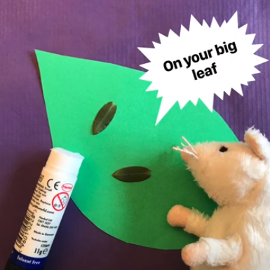
- Draw legs and eyes onto your small leaves. Maybe add spots and stripes to your leaves too.
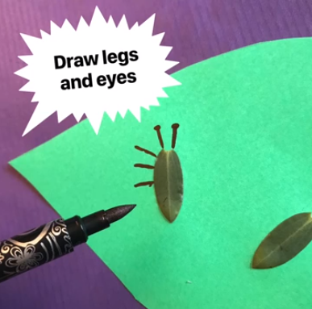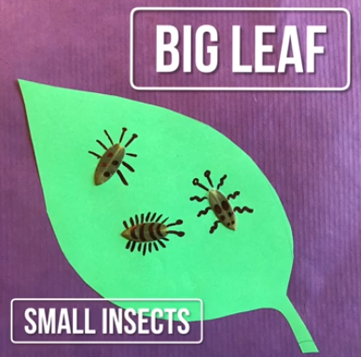
- What other things can you create? Maybe use a big leaf on your even bigger paper leaf. What can you make with the petals? Here are some ideas:
