Seasons

In our 2018 exhibition, ‘Richmond People and Places’, we celebrated local landscapes. There were scenes from spring, summer, autumn and winter. What is your favourite season?
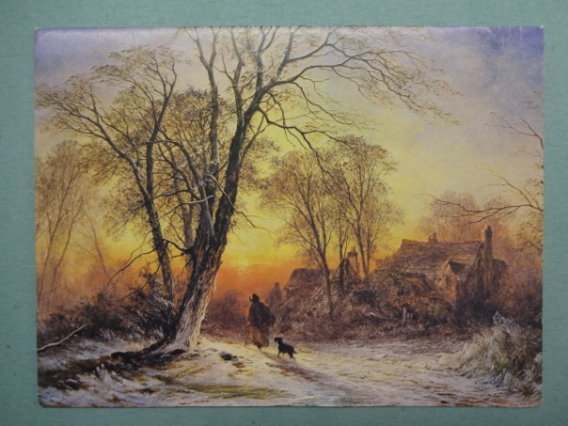
Look at these images from the Borough Art Collection to inspire you:
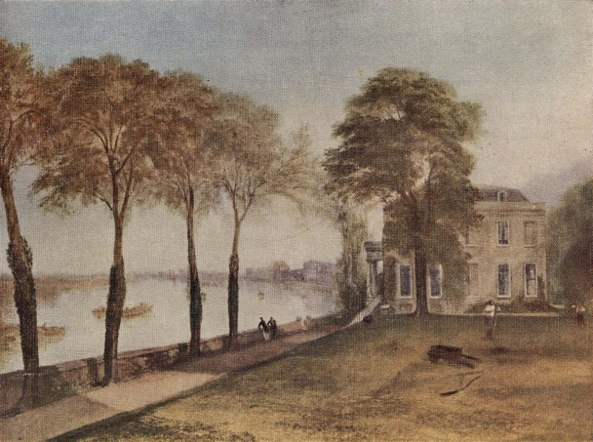
‘Mortlake Terrace Early Summer Morning’ by JMW Turner, 1826 ‘A Winter Evening’ by Caroline Williams, 1978
Print from a publication
Draw a scene from your favourite season. What is the weather like? Is there snow, rain or sunshine? What do the trees and leaves look like?

