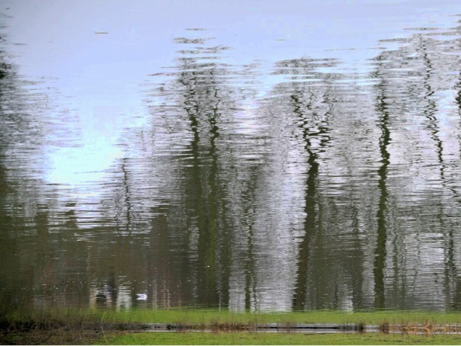
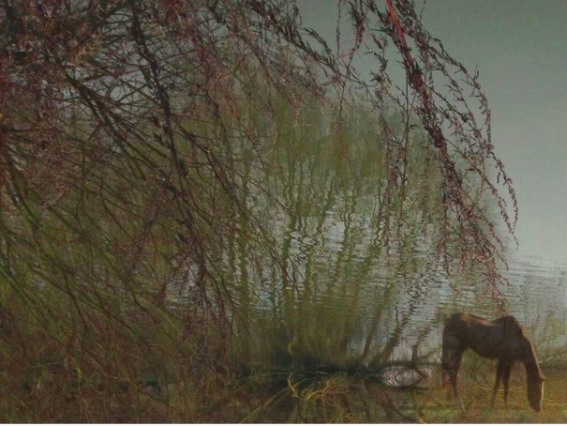
Your Ideal Place!

In 2017 there was an exhibition called ‘Equine Idyll’ in the Stables Gallery. It was inspired by an idyllic country retreat and was by Bethe Bronson and Laura Marker.

What would your perfect place look like – would there be boats, horses and grand buildings like there once was here or something completely different?
Draw and collage in the box below.

