See Saw @ Home – Create Shape Owls
You will need:
- Paper rectangles
- Sponge
- Scissors
- Paint
- Brushes
- Round bottle tops
- Cut a small triangle from your sponge.
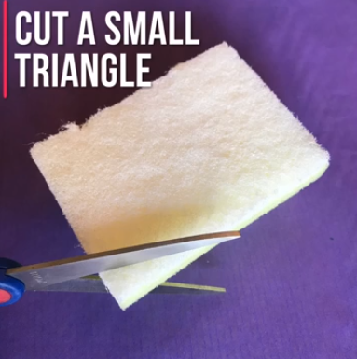
- Brush paint on your bottle top and print it onto your rectangle. You can use a different sized bottle lid to add the colour of the eyes. Using your brush, add two small dots into the eyes.

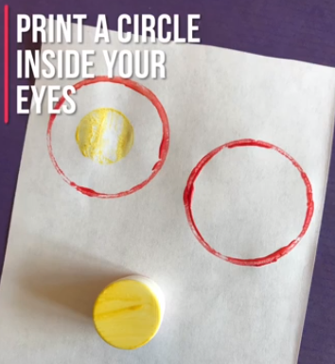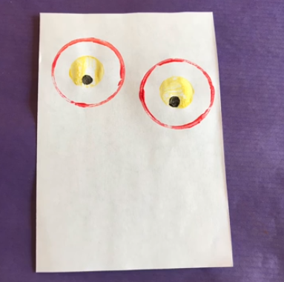
- Mix red and yellow paint to make orange and place your sponge triangle into the colour and print it onto your paper.
