See Saw @ Home – Create Accidental Owls

For this activity, we are taking inspiration from this image by Hugh Lee, which is called Accidental Owls. It is an assemblage and it is made up of some objects that have been decorated to make them look like an owl. We are going to do the same.
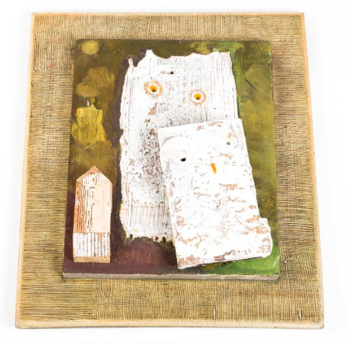
You will need an adult with a camera and a good imagination.
- Have a look around your house or outside to find some circles. You will need two. We used daisies.
- Look for a rectangle for the owl’s body. It needs to be bigger than the eyes. We found a log.
- Find a triangle for the beak. We used a leaf.
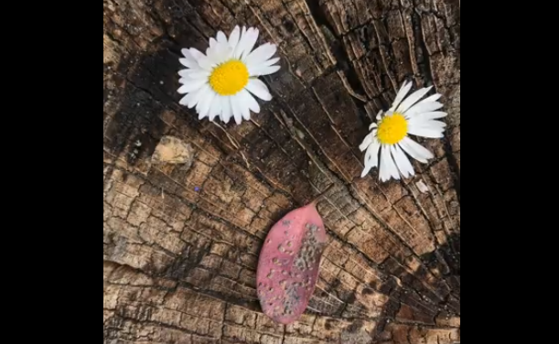
- Take a photo.
- What other things can you use? Look for circles, rectangles and triangles.
