See Saw @ Home – Create Line
An activity to do together with a grown up.
You will need:
- Scissors
- Pens
- Tape or glue
- Ruler
- Pencil
- Paper

- Use your ruler to draw lines and cut some long strips with your scissors. They should be about 3cm wide, but anything will be fine.
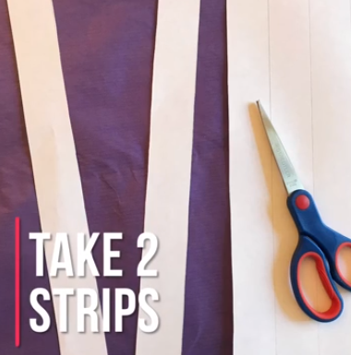
- Decorate the strips with wiggly lines and patterns. We were inspired by worms.
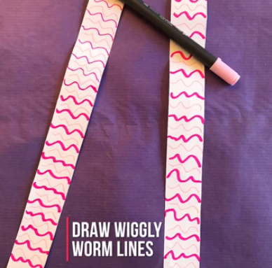
- Stick the two pieces of paper together at the end, so that the strips are at a right angle to each other (like the corner of a square).
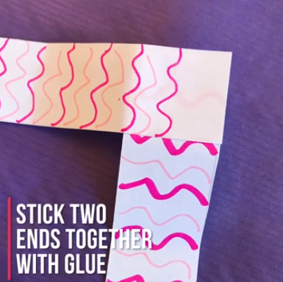
- Fold the strips over each other: If the horizontal strip is strip A and the vertical one is strip B, then fold B upwards over A and folding at the join. Then fold A over B, doing the same. Keep going, folding B and then A over the top until you run out of paper.
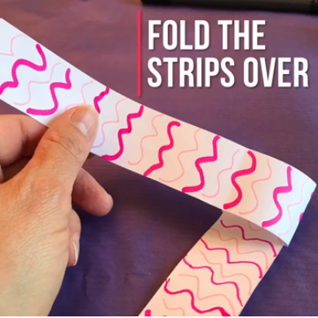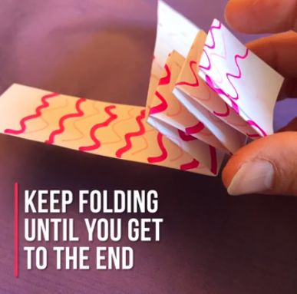
- Glue the last bits of each strip together at the end. This is your worm or snake body.
- Draw a worm or snake head and cut it out.
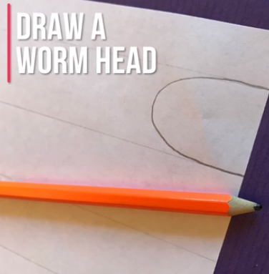
- Draw on a face and stick it to the end of your body. You can even add a tongue.
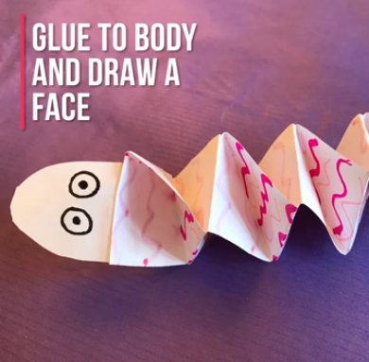
- Make another.
