See Saw @ Home – Create Colour Walkthrough
For this activity, you will need:
- Some card - it could be from a clean, dry food packet i.e. a cereal box
- A piece of paper - any colour
- Some scissors - always supervise and help children with scissors
- Sellotape
- Colouring pencils or pens
- Take a cardboard box from your recycling box and unfold it so it is flat.
- Fold it in half.
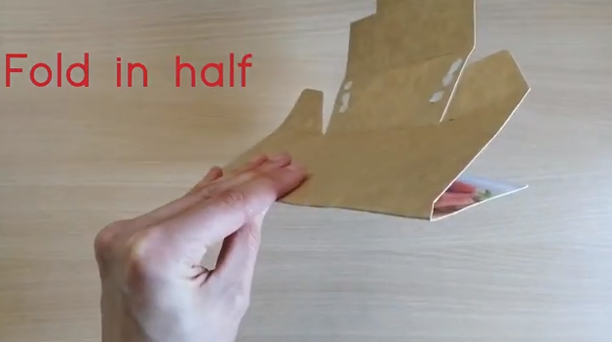
- Draw half a butterfly along the fold and ask an adult to help cut it out.
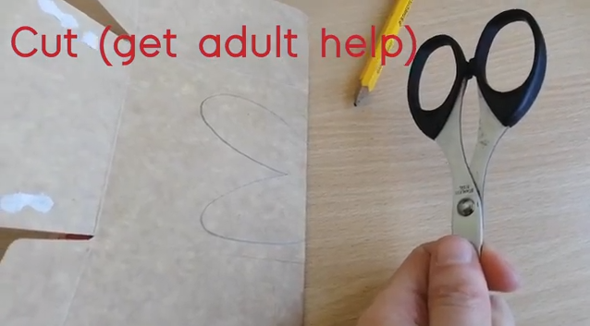
- Unfold the shape to reveal your butterfly. Now draw around this shape onto a piece of coloured paper and cut this shape out as well.
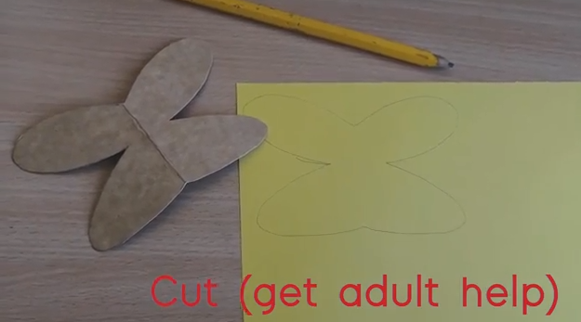
- Glue the paper butterfly onto your cardboard so that you can no longer see the packaging on the box (make sure that you stick your butterfly the right way around, so the two shapes fit together). Fold along the centre.
- Decorate the butterfly with the pattern that you want on both sides. What colours will you use? Can you make the pattern symmetrical, so it is the same on both sides?
- Take your left-over box (which you cut your original butterfly shape from) and cut a strip of card. Fold it over your finger to get the right size for your finger and tape it in place. Tape it to the underside of your butterfly.
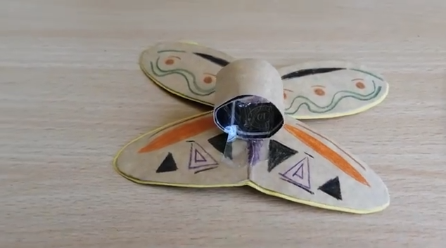
- Take your butterfly ring for a walk.
