See Saw @ Home - Create Collections
You will need:
- Any containers you can find. Maybe an egg box, other recycling or an old Tupperware box.
- A collection of things from the garden: twigs, leaves, flowers (don’t pick them).
Put your collected objects together in your box.
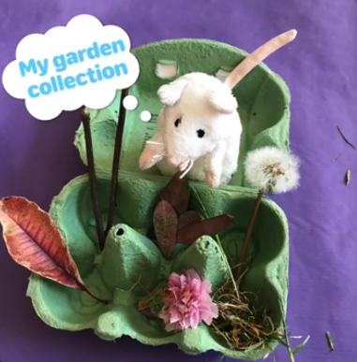
You can make other collections too:
- What about things you love, such as small toys or things that you find pretty, such as a nice post-it note, a rubber with a pretty pattern or a small toy car.
- Or a collection about you. You and a grown up can draw some pictures together, such as something you would like to be, what you like to do, your favourite food, something you don’t like and something you love.
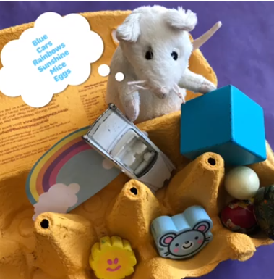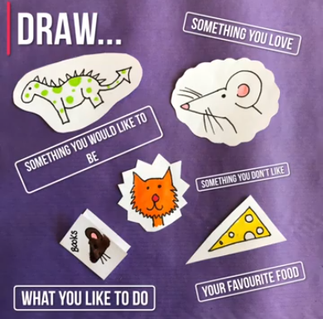
What other collections could you make?

